Why Advertisers Need to Stay on Top of The Latest Digital Channels
Student’s Name
Institution Affiliation
Course Number and Name
Instructor Name
Date

Why advertisers need to stay on top of the latest digital channels
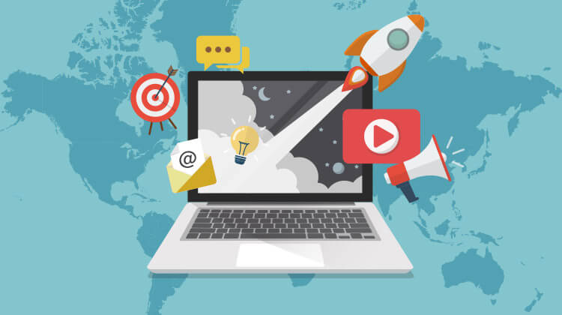
(Andrus, 2020)
In the past decades, the world has evolved with some noticeable changes, including the emergence of new technologies. The world has increasingly moved from analog to digital advancements. Digitalization has significantly affected the method and channel of doing things. For instance, the use of posters in advertising businesses and other elements has shifted to the dominancy of using social media platforms for advertising (Muminova, 2014). other companies and organizations, including Amazon, have turned to the online marketing platform that has witnessed increased company yields. The main goal of adverts is to gather possible customers' attention to a particular product or service. Likewise, the adverts may be meant to gather the thoughts of the customers. Advertisers need to stay on top of the latest digital channels to enhance and increase their outreach to customers.
The flexibility offered by the latest digital channels is one of the reasons that advertisers have to consider. These digital platforms include LinkedIn, Twitter, and Facebook. These channels offer digital advertising, which may consist of several channels that reach a significant number of audiences. The more the platforms, the more the capability of reaching more audiences. Likewise, the speed of advertising in the latest digital channels is high. It is easier to be viral for the advert, enhancing the awareness of the services or product when the advertisers maintain their dominance in the latest digital platforms. More importantly, the dominance in the latest digital media provides extra information about the competitors increasing the ability to shift from one strategy to another. Therefore, a company or organization can change management strategies to compete appropriately with the advertisers' rest. Finally, the process of digital marketing can be measured easily to gauge where the audience reached is high (Tomita, 2016). this helps the advertisers gauge the proper and advantageous channel to reach out to the main customers. Therefore, advertisers need to stay on top of the latest digital media.
References
Andrus, A. (2020, April 22). What is digital marketing, and how do I get started? Disruptive Advertising. Retrieved October 27, 2020, from https://www.disruptiveadvertising.com/marketing/digital-marketing/
Muminova, O. (2014, January 23). How to stay ahead in the digital age? The Guardian. Retrieved October 27, 2020, from https://www.theguardian.com/advertising/digital-media-trends-staying-ahead
Tomita, M. (2016, September 19). Seven reasons digital advertising wins - Marketo. Marketo Marketing Blog - Best Practices and Thought Leadership. Retrieved October 27, 2020, from https://blog.marketo.com/2015/11/join-the-big-league-7-reason-to-go-digital-with-your-advertising.html

